
SYLLABUS
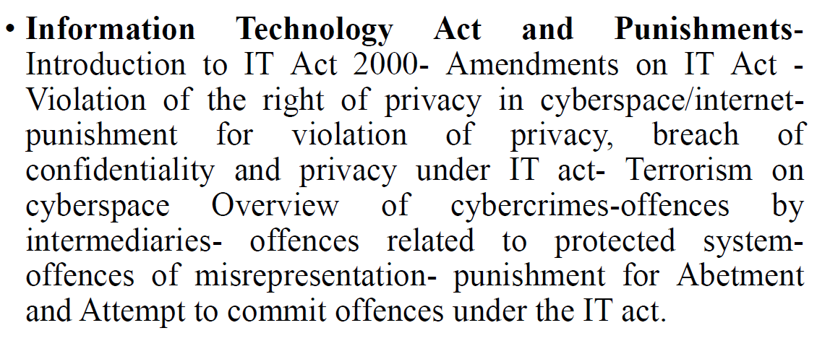

[1] IT ACT 2000
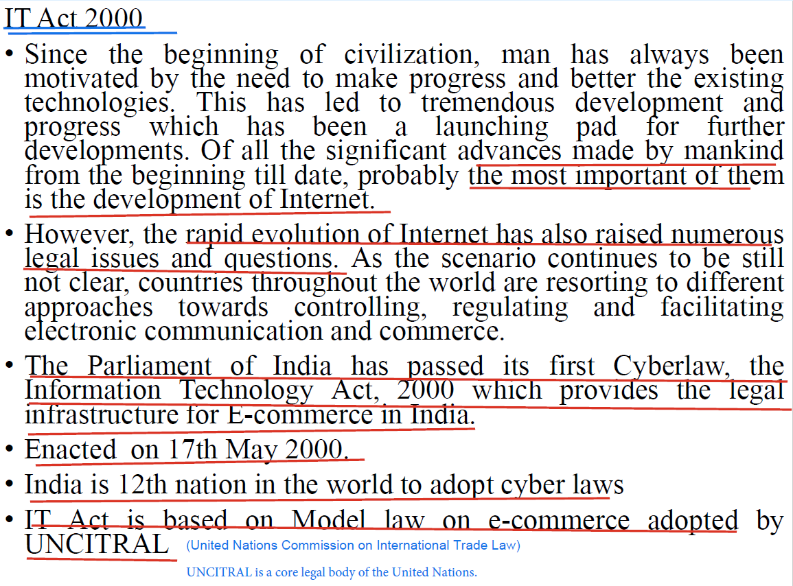
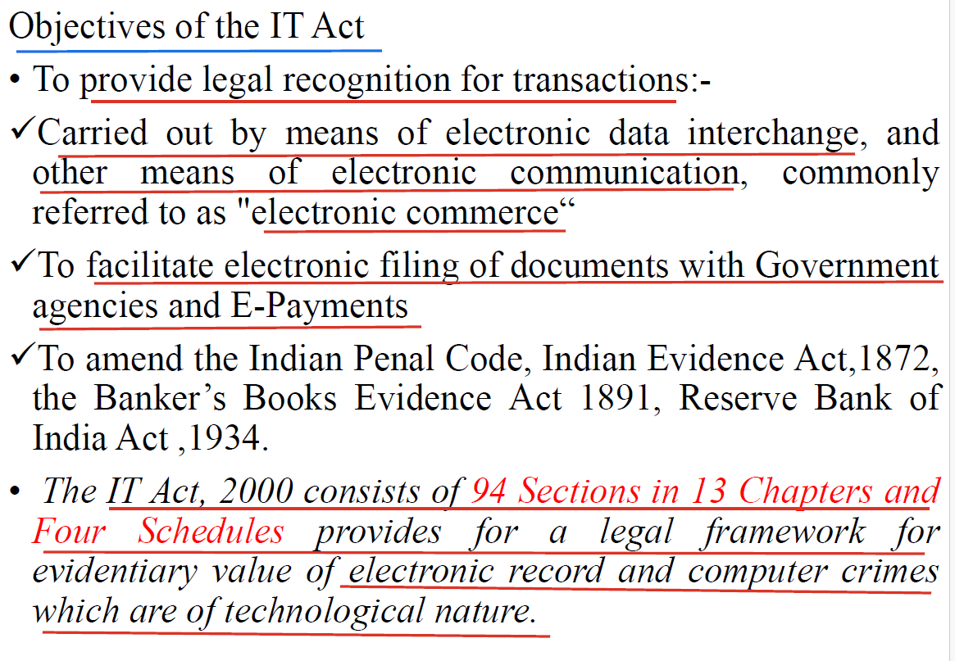
QN) Primary objectives of the Information Technology Act, 2000 (India)
- Legal recognition of electronic transactions – give e-mails, e-contracts, digital signatures and electronic records the same validity as paper documents.
- Enable secure digital authentication – establish the framework for digital signatures, certifying authorities and a Controller of Certifying Authorities (CCA).
- Facilitate e-commerce & e-governance – remove legal barriers so businesses and government can offer services and conclude contracts online.
- Define and criminalize cyber-offences – create specific offences (hacking, identity theft, data theft, virus creation, etc.) and corresponding penalties.
- Provide civil remedies for data-related wrongs – allow claims for unauthorised access, damage to computer resources, privacy violations, etc., adjudicated by specialised cyber-adjudicating officers and the Cyber Appellate Tribunal.
- Establish liability rules for intermediaries – spell out “safe-harbour” protections and due-diligence obligations for ISPs, platforms, cloud hosts, etc.
- Enable regulation & oversight – empower the Central Government to make rules (e.g., CERT-In Rules, Intermediary Guidelines, CERT alerts) and issue directions for cyber-security, interception and data retention.
- Promote international cooperation – align India’s cyber laws with global models (UNCITRAL) and facilitate cross-border investigation and evidence sharing.

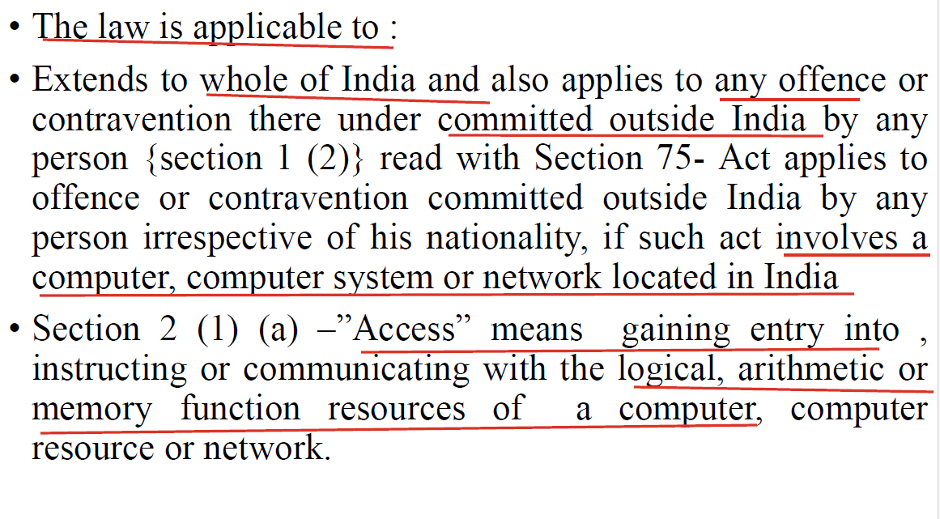
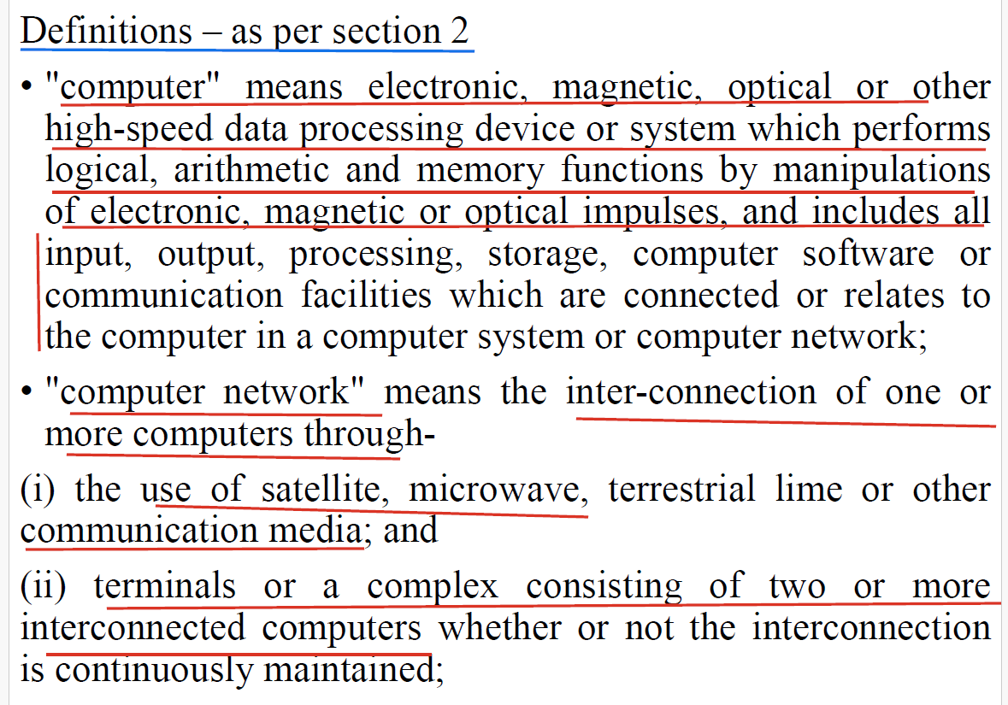

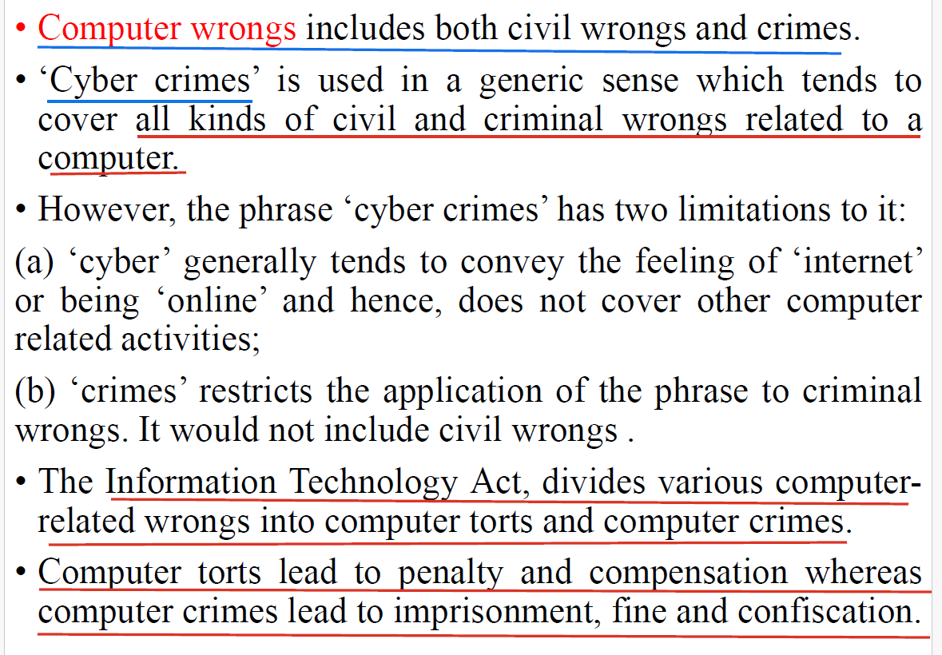

Qn ) Analyse the key aspects and provisions of IT Act 2000 (6M)

Key Aspects of the IT Act, 2000

1. Legal Recognition of Electronic Records (Section 4)
- Provides that electronic records are legally valid and equivalent to paper-based records.

2. Legal Recognition of Digital Signatures (Section 5)
- Grants legal status to digital signatures, enabling authentication of electronic documents.

3. E-Governance (Sections 6–10A)
- Allows filing of applications, forms, and documents with government agencies electronically.
- Enables issuance of licenses and permits via digital format.

4. Regulation of Certifying Authorities (Sections 17–34)
- Establishes a framework for licensing and regulating Certifying Authorities (CAs) who issue digital signature certificates.

5. Cybercrimes and Offenses (Sections 43–74)
Covers a wide range of cyber offenses, including:

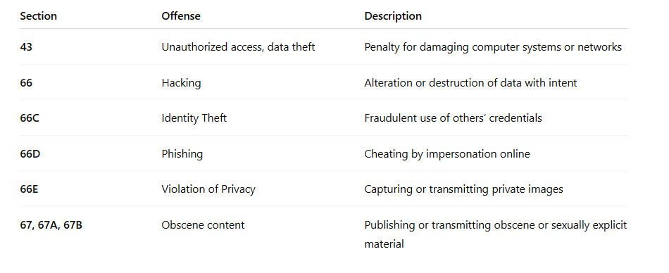6. Cyber Terrorism (Section 66F)
- Covers unauthorized access to critical systems with intent to threaten national security.
- Punishable with life imprisonment.

7. Protection of Sensitive Data (Section 43A)
- Imposes liability on companies for failing to protect sensitive personal data.

8. Intermediary Liability (Section 79)
- Intermediaries (e.g., ISPs, social media platforms) are not liable for third-party data if they observe due diligence and act upon receiving knowledge of illegal content.

9. Breach of Confidentiality and Privacy (Sections 72 & 72A)
- Punishes unauthorized access and disclosure of personal data or information.

Key Amendments: IT Amendment Act, 2008
- Introduced provisions for cyber terrorism, identity theft, and data protection.
- Expanded the scope of digital crimes.
- Strengthened penalties for offenses.
- Included electronic signatures along with digital signatures.

--------------------------------------------------------
Qn) Explain the different sections in the IT Act 2000 related to women and children.(2 times) (6M)

Sections in the IT Act, 2000 Related to Women and Children
The Information Technology (IT) Act, 2000 includes several provisions that aim to protect women and children from cybercrimes, especially from online abuse, exploitation, and indecent content. These sections deal with privacy, obscenity, and cyber harassment.

Key Sections of the IT Act 2000 for Women and Children

1. Section 66E – Violation of Privacy
Punishes the intentional capture, publishing, or transmission of the image of a private area of any person without consent.
- Common Offense: Circulating intimate or indecent photos without consent (e.g., in revenge porn).
- Punishment:
  - Imprisonment up to 3 years
  - Fine up to ₹2 lakh, or both

2. Section 67 – Publishing Obscene Material in Electronic Form
Penalizes the publication or transmission of obscene content online.
- Common Offense: Sharing pornographic content, abusive images, or vulgar texts.
- Punishment:
  - First conviction: 3 years imprisonment + ₹5 lakh fine
  - Subsequent conviction: 5 years imprisonment + ₹10 lakh fine

3. Section 67A – Publishing Sexually Explicit Material
Deals with material that is not only obscene but sexually explicit in nature.
- Example: Sharing pornographic videos or images over social media or messaging apps.
- Punishment:
  - First conviction: 5 years imprisonment + ₹10 lakh fine
  - Second: 7 years imprisonment + ₹10 lakh fine
4. Section 67B – Child Pornography
Specifically targets child sexual abuse material (CSAM).
- Prohibits creation, publishing, browsing, downloading, or advertising content involving children in a sexually explicit act.
- Punishment:
  - First conviction: 5 years imprisonment + ₹10 lakh fine
  - Second: 7 years imprisonment + ₹10 lakh fine

5. Section 72 – Breach of Confidentiality and Privacy
Punishes unauthorized access and disclosure of personal information.
- Relevant in cases where a woman or child’s private data is accessed (like photos or chats) and shared without consent.
- Punishment:
  - 2 years imprisonment
  - Fine up to ₹1 lakh, or both

Supporting Laws from Other Acts:
In many cases, the IT Act works alongside other laws to ensure protection, such as:
- IPC Section 354D – Cyberstalking of women
- POCSO Act, 2012 – Sexual offenses against children using electronic means
- Indian Evidence Act, 1872 – Admissibility of digital evidence

Examples of Relevant Crimes:
- Circulating morphed images of a girl on WhatsApp or Instagram
- Posting child pornographic material on a website or social media
- Cyberstalking or harassing women through emails or messages
- Threatening to leak private photos or videos

-------------------------------------------------------------------------
Qn) Explain the objectives and features of Information Technology Act 2000. (2 times)

Key Features of the IT Act, 2000

1. Legal Recognition of Electronic Records and Signatures
- Gives legal validity to electronic documents and digital signatures.
- Enables use of e-commerce and electronic contracts.

2. Facilitates Electronic Governance (E-Governance)
- Allows government agencies to accept, file, and issue documents electronically.
- Promotes efficient public service delivery.

3. Defines Cybercrimes and Prescribes Penalties
- Covers offenses like:
  - Hacking
  - Data theft
  - Cyberstalking
  - Phishing
  - Cyber terrorism
  - Identity theft
- Specifies civil and criminal liabilities.

4. Regulates Certifying Authorities (CAs)
- Establishes a system for issuing Digital Signature Certificates.
- Provides for the appointment of the Controller of Certifying Authorities (CCA).

5. Protects Sensitive Personal Data
- Section 43A mandates compensation for failure to protect data by companies or intermediaries.

6. Recognizes Cyber Offenses Against Women and Children
- Sections 66E, 67, 67A, and 67B address:
  - Privacy violations
  - Obscene material
  - Child pornography

7. Liability of Intermediaries (Section 79)
- Provides conditional immunity to platforms (like social media) if they act on illegal content once notified.

8. Cyber Appellate Tribunal
- Set up for adjudication of cyber disputes (merged with TDSAT in later updates).

9. Jurisdiction in Cyber Matters
- The Act applies to offenses committed outside India if the computer system affected is located in India.

10. Cyber Terrorism (Section 66F)
- Defines and punishes cyber terrorism with life imprisonment for attacks on critical infrastructure or national security.

---------------------------------------------------------------

Offences under the IT Act
Indian laws related to cyberspace and the internet are covered under the Information Technology (IT) Act.
The IT Act includes two types of penalties for violating its provisions:

Types of Penalties
[i] Civil Liability
  - Payment of damages or compensation for the harm caused.
[ii] Criminal Liability
  - Punishment for committing offences.
  - Punishment can be in the form of:
    - Imprisonment
    - Fine
    - Or both

[i] Civil Liability

Penalty and Compensation for Damage to Computer or Computer System

Relevant Law: Section 43 of the IT Act
If any person does the following without permission of the owner or the person in charge of a computer, they are liable:

Acts That Lead to Penalty
- Accesses any computer, computer system, computer network, or computer resource.
- Downloads, copies, or extracts any data, computer database, or information from computer, computer network or information in removable media.
- Introduce a Virus or Contaminant -Installs a computer virus or contaminated software into any system.
- Damage Systems or Programs - Causes damage to a computer, network, data, database, or any computer programs.
- Disrupt Computer Services -Disrupts or causes trouble in the working of any computer system or network.
- Deny Access to Authorized Users - Blocks or denies access to someone who is authorized to use a system.
- Help Others Access Illegally -Assists anyone in getting unauthorized access to a computer or network.
- Manipulate Services -Uses someone else's account or services by tampering or manipulating the computer/network.
- Delete or Alter Data - Deletes, destroys, or modifies data in a way that reduces its usefulness or value.
- Steal or Modify Source Code
  - Steals, hides, destroys, or changes any computer source code (used in software), especially to cause damage.
If any of the above actions are done with the intention to cause harm, the person will be liable to pay compensation up to ₹1 crore to the affected party.

Key Terms Defined Under Section 43
The section defines the following technical terms:
- Computer Contaminant
  - Harmful software that affects normal operations.
- Computer Database
  - A collection of organized data stored on a computer.
- Computer Virus
  - A program that can replicate itself and harm computer functions.
- Computer Damage
  - Harm caused to systems, data, or operations.
- Computer Source Code
  - The base programming language code used to run software.
#########################################################################

[ii] Criminal Liability / Criminal Offences / Cyber crimes
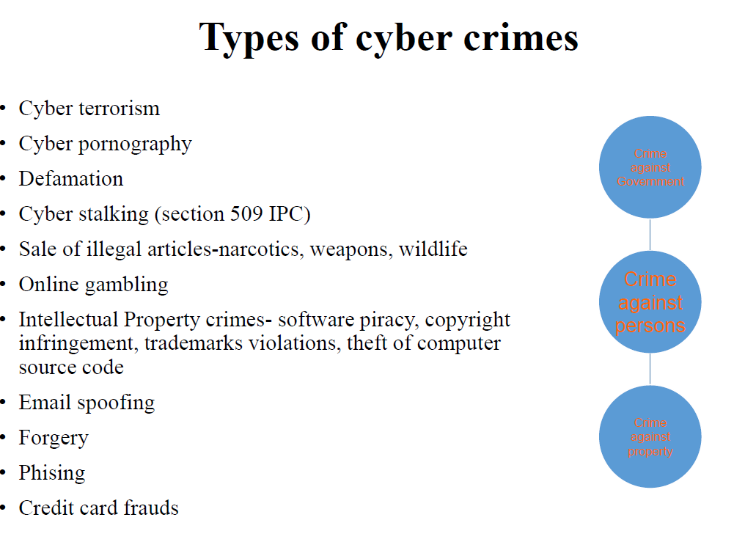

Obscenity & pornography in Cyberspace
Cyberspace has seen increasing misuse for pornography and obscenity, especially involving child pornography. These acts are criminal and are governed by various laws in India.

Pornography vs Obscenity
- Pornography: Originally referred to art or literature about sex and sexual themes.
- Obscenity: Refers to content that is offensive to public morals.
- They are different concepts under the law.
- Obscenity depends on time, culture, and societal values. What was obscene in the 19th century might not be considered so today.

Indian Laws on Cyber Obscenity

Section 67 of the IT Act, 2000
- Criminalizes publishing, transmitting, or causing transmission of
  - Any lascivious material or
  - Anything appealing to prurient interest or
  - Material that can deprave and corrupt people.
"Lascivious" means having or showing an excessive or offensive sexual desire.
"Prurient interest" refers to an excessive, morbid, or unhealthy interest in sexual matters.
Punishment:
- First offense: Up to 3 years jail + ₹5 lakh fine.
- Repeat offense: Up to 5 years jail + ₹10 lakh fine.
⚠️ No need to prove intent or guilty mind (mens rea) for conviction (a person can be punished for an offence even if they did not intentionally or knowingly commit it.)

Child Pornography – Section 67B (IT Amendment Act, 2008)
Prohibits:
- Publishing/transmitting content with children in sexually explicit acts.
- Creating, downloading, advertising, or sharing such content.
- Inducing children into online sexual relationships.
- Online child abuse or recording any such act.
Punishment:
- First conviction: Up to 5 years + ₹10 lakh fine.
- Second conviction: Up to 7 years + ₹10 lakh fine.

Case Example: “Bandit Queen” Case
- A film about Phoolan Devi was banned for obscenity by Delhi High Court.
- Supreme Court later lifted the ban, allowing artistic freedom under certain protections.

Cyber Café Rules (2011)
- Cyber cafés must verify identity of users before allowing internet access.
- Acceptable ID proofs:
  - Aadhar, Passport, Voter ID, PAN Card, Driving License, etc.

Real Case Example
- A pornographic website by students listed sexual details of girls and teachers.
- Case registered under Section 67; a student was arrested.
----------------------------------------------------------------------------------------------

Hacking on Cyberspace and Internet

Hacking
- Hacking is the act of gaining unauthorized access to a computer system, network, or data.
- It is often done without the owner's permission and involves breaking into systems to steal, damage, or misuse information.
- Hackers usually use the internet to access remote systems and perform illegal activities such as data theft or disruption.

Growing Threat of Hacking
- Hacking is becoming very common and dangerous.
- Hackers use the internet to:
  - Enter into computer systems,
  - Steal or destroy data,
  - Spread harmful software,
  - Or even damage important systems.
- This can cause huge losses and even national security threats.

Law Against Hacking – Section 66 of the IT Act, 2000
- If anyone dishonestly or fraudulently hacks a computer system, it is a crime.
- Punishment: Jail up to 3 years, or a fine up to 5 lakh rupees, or both.

Section 43 of the IT Act
- If someone destroys or accesses a computer without permission, they will be punished even if it's not full hacking.
- This section covers damaging data, changing settings, or disrupting systems.
- Punishment: Fine up to 1 crore rupees (civil liability).

Types of Hackers
There are various types of hackers, and they differ based on their intention and behavior.
- White hat hackers are ethical hackers who use their skills to find and fix security issues to help organizations.
- Black hat hackers are those who use their knowledge to commit crimes such as stealing data or damaging systems.
- Grey hat hackers are individuals who break into systems without permission but do not have harmful intentions, though their actions are still illegal.

Motivation Behind Hacking
- Many hackers do it for fun, curiosity, personal challenge, or to prove their technical abilities.
- Others may hack for revenge, financial gain, political reasons, or to cause disruption to a competitor or government.
- Some young people, including minors, are drawn to hacking without understanding the consequences, but they can still face legal action.

Script Kiddies and Tools
- Many hackers, especially inexperienced ones, use readymade programs called "script kiddies" to launch attacks without advanced knowledge.

- These tools are easily available online and allow users to hack systems with minimal effort, though they still carry legal consequences.

Qn) Define the term hacking and its essentials. (4M)

Definition of Hacking (as per IT Act, 2000):
Hacking refers to the unauthorized access or control over computer systems, networks, or digital data, usually with malicious intent such as theft, destruction, or manipulation of data.
Under the Information Technology Act, 2000, Section 66 defines hacking in the context of computer systems:
Section 66 – "If any person, with the intent to cause or knowing that he is likely to cause wrongful loss or damage to the public or any person, destroys or deletes or alters any information residing in a computer resource or diminishes its value or utility or affects it injuriously by any means, he shall be guilty of hacking."

Essentials (Key Elements) of Hacking:
To constitute hacking under the IT Act, the following essentials must be met:
- Unauthorized Access or Intrusion:
  - The person gains access to a computer system or network without permission.
- Intent or Knowledge:
  - The act is done intentionally or with knowledge that it could cause harm or loss.
- Alteration or Destruction of Data:
  - The hacker alters, deletes, damages, or steals data or software.
  - This includes modifying information, injecting malware, or crashing systems.
- Causing Wrongful Loss or Damage:
  - There must be an impact, such as financial loss, disruption of service, or loss of data integrity or confidentiality.

Examples of Hacking:
- Gaining access to a company's server to steal client data.
- Altering exam results on a university website.
- Defacing a government website.
- Installing ransomware to lock files and demand payment.

Cybercrime and Minors
- Many children under 18 get involved in hacking.
- They may not fully understand it’s illegal.
- But under the law, even minors can be punished.

Court Judgments and Legal Enforcement
Under Section 77B of the IT Act, Courts in India (like Kerala High Court) have confirmed:
  - Hacking is a punishable offence.
  - Even if a hacker does not succeed, an attempt to hack is punishable.
  - Punishment can include jail and/or fine under Sections 66 and 43.

Cyber Terrorism under Section 66F
- If someone knowingly tries to hack or damage systems that affect national security, they can be charged with cyber terrorism.
- This is a serious offence.
- Punishment: Jail up to life imprisonment or a fine.

[2] Amendments on IT Act
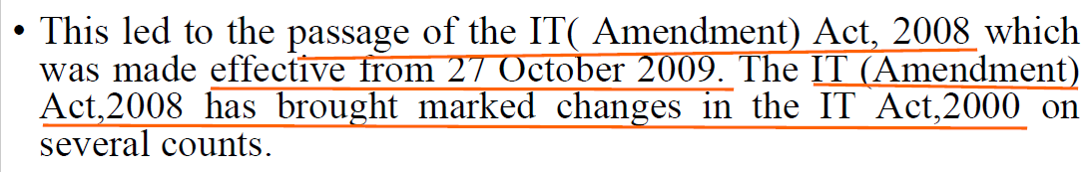
Amendments are :
- Electronic Signatures Introduced: India now legally recognizes electronic signatures for online contracts and transactions.*
- Corporate Responsibility (Section 43A): Companies must protect personal information. If they fail and data is misused, they must pay compensation.
- Compensation for Negligence: People can get compensation if a company doesn't protect their personal data properly.
- Distinction Between Contravention and Offence: The law now separates minor violations (contraventions) from serious crimes (offences) based on intent (mens rea).

Contravention vs Offence

Contravention-: A less serious violation of the law.
- Punishment: Usually involves penalty or fine, not imprisonment.
- Examples:
  - Sending spam emails.

Offence- : A serious violation or breach of law.
- Nature: Criminal in nature.
- Punishment: Can include imprisonment, fine, or both.
- Examples:
  - Hacking.
- Liability of Intermediaries: Websites or platforms (like social media) must remove illegal content quickly if informed, or they will be punished.
- Power of Controller: A government officer (Controller) can investigate and check any computer system for violations.
- Adjudication Powers: Special officers can now handle cyber disputes involving up to ₹5 crore. Cases above this go to civil courts.
- Cyber Appellate Tribunal: The law has changed the structure of the Cyber Appellate Tribunal. It replaces the earlier body that used to handle appeals related to cyber law cases.The Telecom Disputes Settlement and Appellate Tribunal (TDSAT) now performs this function. It hears appeals against the decisions made by the Adjudicating Officer in cybercrime cases.
Cyber Appellate Tribunal was a special court created under the Information Technology (IT) Act, 2000 in India to hear appeals from people or companies unhappy with decisions made by the Adjudicating Officer in cybercrime and data protection cases.
- New Cybercrimes Added: The law now punishes sending offensive messages, cyberstalking, identity theft, and online fraud.
Cyberstalking is when someone uses the internet or electronic devices to harass, threaten, or stalk another person repeatedly

Examples of Cyberstalking:
- Sending unwanted messages again and again through email, social media, or messaging apps.
- Tracking someone’s location using GPS or social media check-ins without permission.
- Posting threatening or embarrassing content online about someone.
- Creating fake accounts to follow, message, or spy on someone.
- Constantly monitoring or spying on someone’s online activity.
- Section 67C (Data Retention): Companies must save data for a certain time to help in investigations.
- Section 69 (Government Power to Monitor): The government can monitor online activity for security reasons.
- Section 69A (Blocking Websites): The government can block harmful websites and services.
- Section 69B (Monitoring of Traffic Data): Authorities can monitor internet traffic to ensure cybersecurity.
- Section 70 (Protecting Critical Infrastructure): Some computer systems (like in defense or power) are labeled as protected and need strong security.
- Section 77 (Clarification): Some crimes will not lead to jail time, only a fine. Others are more serious and involve both jail and fine.
- Section 77B (Serious Cyber Crimes): Major cybercrimes now mean jail time and are non-bailable (you can't easily get bail).

[3] VIOLATION OF THE RIGHT OF PRIVACY ON CYBERSPACE /

INTERNET

Right to Privacy on Cyberspace/Internet

Understanding Privacy
- Privacy is not absolute – It varies in meaning for different people.
- It involves:
  - Keeping personal matters out of public view.
  - Allowing individuals or groups to decide what to share & to what extent.
  - The right to communicate or not communicate personal information.

Nature of Privacy Rights
- Subjective in nature – Depends on:
  - Individuals
  - Regions
  - Societies
- Difficult to define and protect – Acceptance and realization vary across countries.

Expression of Privacy
- Often described as the "right to be left alone."

Legal Recognition of Privacy

European Convention on Human Rights (1950)
- Article 8 gives everyone:
  - Right to respect for private/family life and communication.
  - Protection from interference by public authorities except:
    - In line with the law.
    - For public safety, health, morals, or national security.

Privacy in Legal Terms
- Includes rights like:
  - Making personal decisions.
  - Travelling anonymously.
  - Keeping information about oneself private.
  - Freedom from unnecessary data collection.

Contemporary Uses of Privacy
- Applied in areas like:
  - Healthcare
  - Credit reports
  - Protection from surveillance and seizure

Privacy in Indian Legal Context

In India the right to privacy was for the 1st time emphasized by the minority judgement delivered by Justice Subba Rao in Kharak Singh v. State of UP which :
- Emphasized personal liberty:
  - Includes freedom from movement restrictions.
  - Protection from state intrusion into private life.
Kharak Singh v. State of Uttar Pradesh (1962) is a landmark Indian legal case where the right to privacy was discussed for the first time by the Supreme Court of India, though it was not fully recognized at that point.

Context of the Case:
- Background: Kharak Singh, a person accused in a criminal case, challenged police surveillance methods (like night visits to his home) as a violation of his fundamental rights.
- Legal Issue: Whether constant police surveillance violates Article 21 of the Indian Constitution, which guarantees the Right to Life and Personal Liberty.

Judgment:
- The majority of judges did not fully accept that privacy was a fundamental right.
- However, Justice Subba Rao, in his minority judgment, strongly emphasized the concept of personal liberty, stating:
  - Personal liberty includes freedom from unwarranted state intrusion.
  - It covers privacy in the private life of a person.
  - Any act like night surveillance violates personal freedom.

Gobind v. State of Madhya Pradesh
- Supreme Court of India:
  - Recognized right to privacy as a fundamental right, but not an absolute one.

Case Summary: Gobind v. State of Madhya Pradesh
- Facts: The petitioner challenged surveillance measures by the Madhya Pradesh police under the M.P. Police Regulations, claiming they violated his fundamental right to privacy.
- Issue: Whether the right to privacy is a fundamental right under the Indian Constitution.
- Judgment:
  - The Supreme Court of India did not explicitly declare privacy as a fundamental right, but acknowledged that privacy is implicit in the right to life and personal liberty under Article 21.
  - The Court stated that privacy can be restricted in the interest of public safety, order, and morality, but any such restriction must be reasonable and legally justified.

Statutory Protection
- There is no specific law solely for privacy.
- Privacy has been covered under Article 21 of the Constitution (Right to Life and Personal Liberty).

- Case : Rajagopal v. State of Tamil Nadu
  - This case is concerned with publication of a prisoner’s autobiography which contains materials that show close connection between prisoner & IAS,IPS officers who were his partners in several crimes.
  - Supreme court laid down following principles regarding to right to privacy:
    - Right to privacy is implicit in the right to life and liberty guaranteed to citizens of this country. None can publish anything concerning a person’s private life without his consent.
    - The above rule is subject to exception if such publication is based on public records including courts records. Once a matter becomes a matter of public record, the right to privacy no longer exists.

- People’s Union for Civil Liberties v. Union of India declared telephone tapping a serious invasion of privacy.
[4] Punishment for Violation of Privacy, Breach of Confidentiality and Privacy under the IT Act
Qn) Define privacy. What is meant by violation or breach of confidentiality and privacy ? Explain the punishments given for the same. (6M)
- Definition of Privacy:
  - Privacy refers to the right of an individual to control access to their personal information, communications, and life choices. In the digital context, it means protecting one’s data, communications, identity, and online behavior from unauthorized access or misuse.

  - In India, privacy has been recognized as a fundamental right under Article 21 of the Constitution (Right to Life and Personal Liberty), especially after the landmark Puttaswamy judgment (2017) by the Supreme Court.

- In IT (Amendment) Act, 2008, a new provision under the IT Act has been introduced for the purpose of punishment for violation of privacy.

- Section 66E- whoever intentionally or knowingly captures, publishes or transmits the image of a private area of any person without his or her consent, violating the privacy of that person, shall be punished with imprisonment up to 3 years or with fine not exceeding 2 lakh rupees, or with both.

- To be punished, it must be proven that the person meant to do it (intentionally) or knew it was wrong (knowingly). This is called mens rea (guilty mind).
Under Section 77B of the IT Act , this offence is:
- Cognizable – Police can arrest without a warrant.
- Bailable – The accused can get bail easily.
Transmitting information in cyberspace
On cyberspace, with the use of Internet, we provide information to others in many ways. Some of the mediums by which we provide information to others are as follows:
- When we sign on with an Internet Service Provider (ISP), the ISP provides mechanism for connecting the computer to the Internet.
- When we correspond through e-mail we are giving information to the receiver.
- By browsing through Internet we are also relying personal information to websites.
- When we use search engines on Internet the search engines also have the availability to track our searches.
- Instant messaging/chatting/video conferencing methods can be archived, stored and recorded on our computer, which can also affect privacy.
- When other people post a video or photograph online also can affect privacy.
- Even online banking requires a lot of sensitive information over the Internet, which may affect privacy.
- Sometimes many websites use web bugs to track as to who is viewing their pages. The web bugs are tiny graphic images on the web page and record the IP address of the viewer.
- Sometimes direct marketing online newspapers and other businesses have hidden cookies for tracking our web pages so we can account information for future transactions.
- Every spyware is a software that secretly gather the information about the Internet communication without our knowledge.
- Phishing and pharming that deceive us into revealing our personal information.
Phishing and pharming are both types of cybercrimes aimed at stealing personal or sensitive information. Here's a simple explanation of each:

🔐 Phishing is a fraudulent attempt to trick someone into revealing sensitive information like usernames, passwords, or credit card numbers by pretending to be a trustworthy source.

🧪 Pharming is more advanced. It redirects users from legitimate websites to fake ones — without their knowledge, even if they type the correct website address.
Section 72 of IT Act – Penalty for Breach of Confidentiality and Privacy
• If someone gets access to electronic information (like emails, documents, or files) without the consent of the concerned person & they share or leak that information to someone else, then they can be punished with:
- Jail time of up to 2 years, or
- A fine up to ₹1 lakh, or
- Both.
Section 72A - Amendment to IT Act, 2008.
• It applies to any person, including intermediaries (like service providers).
• If a person gets access to personal information while providing services under a lawful contract.
• And they disclose that information:
- Without the person’s consent, or
- In violation of the contract,
- And with intent or knowledge that it may cause wrongful loss or gain,
• Then that person can be punished with:
- Imprisonment up to 3 years, or
- Fine up to ₹5 lakh, or
- Both.
Case : A. Shankar vs. The State
- A case was filed against A. Shankar by the CBCID Cyber Crime Cell.
- He was charged under various laws including Official Secrets Act, IT Act (Sections 43 & 66), & IPC Sections 378, 379 (related to theft).
- Shankar was a Special Assistant in the Directorate of Vigilance and Anti-Corruption.
- He allegedly accessed the Legal Advisor’s computer without permission when the advisor was not present.
- He copied sensitive data using a pen drive and leaked it to the Deccan Chronicle and TV channels like Makkal TV and Jaya TV.
- The leaked content included audio files and confidential information.
- This act harmed the value and usefulness of the information.
- A Commission of Inquiry was set up by the Tamil Nadu Government.
- The Commission found him responsible for the data leak and recommended a criminal case against him.

[5]Terrorism on Cyberspace
Qn) Explain cyber terrorism and how it is defined under ITAct -2008? What are punishments for committing cyber terrorism?

Qn) Explain cyber terrorism and associated threats (6m)

Cyber Terrorism
- Terrorism now includes the use of the internet and cyberspace to spread fear, cause harm, or disrupt nations.
- It involves attacks on computers, networks, or data to threaten people or governments.
- Cyber terrorists can use anonymous and fast communication online to meet their goals.

How Cyber Terrorism Works
- Terrorists use cyberspace for unlawful attacks, threats, and data breaches.
- The goal is to damage important systems like:
  - Government networks
  - Economic and financial systems
  - Military and energy infrastructure

Key Targets
- Specific political, civil, religious, or economic systems.
- Terrorists aim to cause fear and confusion, pushing their own agenda.

Cyber Terrorism vs. Hacking
- Hacker: May access data illegally but not always with intent to harm.
- Cyber Terrorist: Targets specific systems with intent to harm society, cause fear, or damage national infrastructure.

Legal Provision in India – IT (Amendment) Act, 2008
Cyber Terrorism Law
- Whoever does the following is guilty of cyber terrorism:
  - Threatens unity, integrity, security, or sovereignty of India.
  - Tries to strike terror in people.
- Actions that are cyber terrorism:
  - (i) Denying access to authorized computer resources.
  - (ii) Accessing or trying to access systems without permission.
  - (iii) Spreading viruses or harmful programs that can cause injury, death, or damage.
- If someone:
  - Accesses restricted government data without permission.
  - Uses it to harm national security, foreign relations, public order, or morality.

Examples of Cyber Terrorism:
- Attacking a nuclear facility's computer systems to cause a meltdown.
- Hacking into an air traffic control system to disrupt flights.
- Disabling a city’s power grid through a computer virus.
- Stealing classified military data and sending it to enemy states.

Associated Threats of Cyber Terrorism

1. Attacks on Critical Infrastructure
- Disruption of power grids, water supply systems, or air traffic control.
- Shutting down defense or intelligence communication systems.

2. Attacks on Healthcare Systems
- Blocking access to hospital data, disrupting emergency services.
- Ransomware attacks on public health infrastructure.

3. Economic and Financial Disruption
- Attacks on banking systems, stock markets, and online payment networks.
- Theft of confidential trade data to cause instability.

4. Psychological Warfare
- Using social media, fake news, or deepfakes to spread misinformation, create panic, or incite violence.

5. Espionage and Data Theft
- Theft of classified government or military information.
- Unauthorized surveillance or interception of official communication.

6. Denial of Service (DoS/DDoS) Attacks
- Overloading systems to make services like government portals or emergency communication channels unavailable.

Punishment
- Cyber terrorism is a serious crime.
- Punishable with imprisonment up to life for those who commit or help commit the crime.
###########################################################################

Short Answer Questions
- Discuss the ‘Triple Test’ for determining whether a work is obscene or not with the help of landmark case laws.
- What are various types of ‘Hackers’? Is it regulated in the Information Technology Act, 2000 as amended in 2008?
- Explain the punishment for violation of privacy and breach of confidentiality under the Information Technology Act, 2000 as amended in 2008.

[6]Overview of Cybercrimes
Qn) What are the different types of cyber crimes? Explain in detail about cyber terrorism.(2 times)
- IT is now very common in daily life for individuals, businesses, and society. It helps make work faster, more accurate, and efficient, especially in business. People use IT for online banking, telemarketing, and credit/debit card transactions. These developments have also attracted misusers and criminals.

- Criminals use IT to commit cybercrimes, especially in the financial world. Cybercriminals trick people on the Internet using various fraud techniques. A new type of white-collar criminal has emerged online.

- Cybercrimes include:
  - Security frauds by changing or manipulating computer data.
  - Phishing, where fake emails trick people into sharing personal info.
  - Creating false identities and selling that information.
  - Online gambling and digital forgery.
  - Fake documents with someone else’s signature.
  - Selling illegal items like drugs or weapons.
  - Copyright violations on the Internet.

- These cybercrimes show the misuse of the Internet.
- Countries have made cyber laws to stop and punish these crimes.
  - In India, the IT Act was created to control cybercrimes.

Qn) Explain cyber stalking and phishing. (4M)

Cyberstalking

Definition
Cyberstalking is the act of using the internet or electronic communication to harass, threaten, or stalk an individual persistently. It often involves unwanted messages, surveillance, or spreading false information to intimidate or emotionally harm the victim.

Common Forms
- Sending repeated, unwanted emails or messages.
- Tracking someone’s online activity or location without consent.
- Creating fake profiles to harass or defame someone.
- Posting obscene or defamatory content about someone on social media.

Legal Provisions in India
- Section 354D of IPC (added by the Criminal Law Amendment Act, 2013): Specifically deals with stalking, including cyberstalking.
- Punishment: Imprisonment up to 3 years for the first offense (extendable to 5 years for repeat offenders), and/or fine.

Phishing
Phishing is a fraudulent attempt to obtain sensitive information (like passwords, credit card numbers, or bank details) by pretending to be a trustworthy entity via email, message, phone call, or fake websites.

Working
- A victim receives a fake email or message that appears to be from a legitimate source (like a bank or government agency).
- The message usually contains a link to a fake website that looks real.
- When the victim enters personal information, it gets stolen and used for fraud.

Common Targets
- Banking credentials
- Login passwords
- Personal identity documents
- Business email credentials

Legal Provisions in India:
- Section 66C of the IT Act: Identity theft.
- Section 66D of the IT Act: Cheating by personation using computer resources.
- Punishment: Up to 3 years imprisonment and fine up to ₹1 lakh.
How to Stay Safe
- Cyberstalking:
  - Block and report the harasser.
  - Maintain privacy settings on social media.
  - Keep evidence and report to cybercrime authorities.
- Phishing:
  - Do not click on suspicious links.
  - Always check the sender’s email address.
  - Use multi-factor authentication and antivirus protection.
--------------------------------------------------------------------------------------------------
Qn) What do you mean by cyber crimes? Discuss the nature and types of cyber crimes.

Nature of Cyber Crimes
Cyber crimes are illegal activities that are committed using computers, digital devices, or the internet. These crimes can target:
- Individuals
- Organizations
- Governments
- Critical infrastructure
Cyber crimes are borderless, often anonymous, and can occur remotely, making them difficult to detect and prosecute.

Types of Cyber Crimes
Cyber crimes can broadly be classified into three categories:

🔸 1. Crimes Against Individuals
These target a person’s privacy, reputation, or property.
Type | Description
Cyber Stalking | Repeatedly sending threatening or obscene messages to an individual
Phishing | Tricking individuals into revealing personal or financial data
Identity Theft | Using someone’s personal information (e.g., Aadhaar, credit card) without permission
Online Defamation | Publishing false information online to damage someone’s reputation
Cyber Bullying | Harassing or humiliating someone via digital platforms

2. Crimes Against Property
These involve damage or unauthorized access to digital property or data.
Type | Description
Hacking | Unauthorized access to a computer system or network
Data Theft | Stealing sensitive data like customer databases, trade secrets
Denial of Service (DoS) | Flooding a server or network to crash it
Ransomware | Encrypting data and demanding payment for its release
Online Fraud | Fake websites, lottery scams, and business email compromises

3. Crimes Against Government or Society
These threaten national security or public order.
Type | Description
Cyber Terrorism | Attacking critical infrastructure to spread fear or harm national security
Cyber Warfare | State-sponsored hacking or spying against other nations
Dissemination of Fake News | Spreading false information to incite panic or violence
Digital Piracy | Unauthorized distribution of copyrighted content (e.g., movies, software)

Emerging Cyber Crimes
- Deepfake Scams
- Cryptocurrency Fraud
- Online Sextortion
- IoT Device Hacking
- AI-generated Phishing Attacks

###########################################################################

[7] Offences by Intermediaries
Qn-Elaborate the meaning of intermediaries with reference to the IT Act. (4 marks)
Qn- Shed light on the concept of intermediaries and their liabilities under the IT Act. (6M)

“Intermediary” under the Information Technology Act, 2000
“Intermediary, with respect to any particular electronic record, means any person who receives, stores or transmits that record on behalf of another person, or provides any service with respect to that record.”

Examples of Intermediaries
Category | Typical examples
Network & access providers | ISPs (Airtel, Jio), mobile carriers, IXPs
Hosting & cloud services | Data-centre operators, AWS, Azure, Google Cloud
Internet platforms | Social-media sites, video-sharing sites, messaging apps, blogging tools
E-commerce & marketplaces | Amazon, Flipkart, app stores, ticketing or ride-sharing platforms
Search engines & aggregators | Google Search, news/read-it-later services
Payment & transaction facilitators | Payment gateways, UPI apps that merely route instructions
Cyber-cafés, e-mail services, caching or mirror sites | Entities that temporarily store or relay content
The key is that intermediary is handling someone else’s electronic data in a purely technical or facilitative capacity, not creating the data itself. If your core function is mere carriage, caching, hosting or platform provision for content generated by others, Indian law treats you as an intermediary.

Under Section 67C of IT (Amendment) Act, 2008, Liabilities of Intermediaries
- Intermediaries must keep and preserve certain information as directed by the Central Government.
- If an intermediary intentionally or knowingly fails to do so:
  - They may face up to 3 years imprisonment.
  - They may also be fined.*
- This is a cognizable and bailable offence under Section 77B.
- The offence requires mens rea (criminal intent) on the part of the intermediary.

Exemption from Liability (Section 79, Chapter XII)
- Intermediaries are not liable(legally responsible for something) for third-party content (information, data, links) hosted or made available by them, if certain conditions are met.

Conditions for Exemption (Section 79(2)):
- The intermediary must:
  - Only provide access to a communication system.
  - Not initiate, select the receiver, or alter the information.
  - Follow due diligence as required under the law and government guidelines.
(Take proper care and do everything necessary to follow the rules, laws, and instructions provided by the government)

When Exemption Does NOT Apply (Section 79(3)):
- If the intermediary:
  - Helps or encourages illegal acts.
  - Is involved knowingly, or
  - Ignores official notice or knowledge about illegal content and doesn’t act to remove or disable it quickly.
- In such cases, the intermediary becomes liable for the offence.

- "Third party information" means any data handled by the intermediary on behalf of others.

- Intermediaries must preserve data as required or face punishment.
- They are not responsible for third-party content, unless they:
  - Help in the crime, or
  - Fail to act when informed about illegal activity.
Qn) Explain about the offenses committed by the intermediaries.(4M)(2 times).
  - If they have conspired, abetted, or aided in the offense.
  - If they fail to act upon receiving actual knowledge (or notification by the government) about unlawful content and do not remove or disable access to it promptly.
  - If they fail to follow due diligence and other guidelines prescribed by the government.
  - If the intermediary:
- Helps or encourages illegal acts.
- Is involved knowingly, or
- Ignores official notice or knowledge about illegal content and doesn’t act to remove or disable it quickly.

[8] Offences Related to Protected Systems

Qn) Define the term “Secure System” as per the IT Act 2000. (2 times)

A "secure system" is one that ensures the integrity, confidentiality, and authenticity of electronic records and operations. It involves both technical safeguards (like encryption, firewalls, and secure coding practices) and procedural safeguards (like access control policies and auditing processes) to protect data and systems from threats.
As per the Information Technology Act, 2000, the term "Secure System" is defined in Section 2(1) of the Act.

Definition:
"Secure System" means computer hardware, software, and procedures that—
- are reasonably secure from unauthorized access and misuse;
- provide a reasonable level of reliability and correct operation;
- are reasonably suited to performing the intended functions; and
- adhere to generally accepted security procedures.

……………………………………………………………………………………………..

Section 70 of the IT (Amendment) Act, 2008 provides:

1)Protected System Declaration
  - The government can declare any computer system as a "protected system" if it is critical to national security, economy, public health, or safety.
2) Authorized Access
The government can allow certain people (in writing) to access these protected systems
3)Punishment for Unauthorized Access
  - If anyone illegally accesses or tries to access a protected system, they can be:
    - Jailed for up to 10 years
    - Fined
    - Or both
4)Government Responsibility
  - The Central Government will decide and implement rules and security procedures for handling protected systems safely.
- Definition of Critical Information Infrastructure
  - It refers to computer resources whose destruction or failure can seriously affect the country’s security, economy, or health systems.
- Serious Offence
  - Unauthorized access is a serious criminal offence.
  - It is cognizable (police can arrest without a warrant).
  - It is non-bailable (bail is not a right and depends on the judge).
………………………..
Qn)Elaborate the meaning of protected system and the various offenses related to it as defined by the IT Act 2000. (6m)

Meaning of "Protected System" Under the IT Act, 2000
A "Protected System" is a critical computer resource that has been officially designated by the government as requiring the highest level of security due to its importance to national security, public safety, or economic stability.

Offenses Related to Protected Systems
Offenses involving protected systems are treated very seriously due to the sensitive nature of the data and operations involved.

🚫 Unauthorized Access to a Protected System – Section 70(3)
If any person:
- Secures access to a protected system without proper authorization, or
- Attempts to access such a system without permission,
It is considered a criminal offense.

Examples of Offenses
- Hacking into a government defense server.
- Attempting to access the control system of a power grid.
- Planting malware in a nuclear control center’s system.
- Unauthorized maintenance or inspection of servers hosting sensitive banking data.

[9] The Offence of Misrepresentation
Qn) State the offenses of misinterpretation covered by the IT Act.(4M)
- According to Section 71 of the IT (Amendment) Act, 2008, if anyone lies or hides important information to get a license or Electronic Signature Certificate from the Controller or Certifying Authority, they can be punished.

- Certain offenses involving misrepresentation, false information, or deceit are covered under the Act. These relate to actions where individuals intentionally provide incorrect or misleading information to deceive others, particularly in digital or electronic formats.
- Cheating by Personating using Computer Resource-Impersonating someone else to deceive or mislead for fraudulent purposes.
- Identity Theft- Misrepresenting one's identity using someone else's credentials. Fraudulent or dishonest use of another person's electronic signature, password, or any other unique identification feature.
- Breach of Confidentiality and Privacy- Misuse or misrepresentation of information obtained under legal authority.
- Compensation for Failure to Protect Data- Misrepresenting or failing to secure data can be grounds for liability. If a body corporate handling sensitive personal data fails to implement reasonable security practices, causing wrongful loss or gain.
The punishment can be:
- Jail for up to 2 years, or
- A fine up to ₹1 lakh, or
- Both.
This offence is:
- Non-cognizable (police cannot arrest without permission from the court), and
- Bailable (you can get bail), as per Section 77B of the Act.

[10] Punishment for Abetment and Attempt to Commit Offences under the IT Act

Qn- Define abetment and punishments for abetment under the IT Act.

Abetment-Definition
Section 84-B of the IT Act says that “abet” has the same meaning as in section 107 of the Indian Penal Code (IPC).
Under IPC 107, a person abets an act when they:
- Instigate someone to do it;
- Conspire with others for its commission; or
- Intentionally aid the act by any act or illegal omission.
Thus, for any offence listed in the IT Act (hacking, identity-theft, etc.), you abet that offence if you instigate it, conspire for it, or intentionally give help that facilitates it.

Abetment (Helping Someone Commit a Crime)- Section 84B
- Under Section 84B of the IT (Amendment) Act, 2008:
  - If a person helps (abets) someone else commit an offence under the IT Act, and that offence happens because of their help,
  - And if there is no specific punishment mentioned for abetment,
  - Then they will get the same punishment as the main offence.

How Abetment Can Happen
- A person may instigate someone to commit the crime.
- They may be part of a conspiracy (a plan) to commit the crime.
- They may assist the main offender in carrying out the crime.
This is similar to how abetment is defined in Section 107 of the Indian Penal Code (IPC).

Punishment

Punishment under IT Act 84-B
Scenario | Punishment
The principal cyber-offence is actually committed as a result of your abetment | Same penalty as the main offence (fine and/or imprisonment prescribed for that offence).
The offence is not ultimately committed | Up to 1 year’s imprisonment.
Example: If you encourage or help someone commit a cybercrime, you will be punished just like the person who committed the crime.

Attempt to Commit an Offence- Section 84C
- Under Section 84C of the IT (Amendment) Act, 2008:
If someone tries to commit an offence under the IT Act and does any act towards it, even if the offence is not completed, they will be punished. This is because the intention and action taken are enough to be considered a punishable attempt.
Punishment
- If there is no specific punishment mentioned for the attempt, then:
  - The person can be jailed for up to half of the maximum jail term of the completed offence.
  - They can also be fined.
  - Or they may get both jail and fine.
Example: If someone tries to hack a system but fails, they can still be punished — possibly with half the punishment of a successful hacking attempt.

- Even if the crime doesn’t happen, trying or helping is still a serious offence.
- These rules make sure that people planning or supporting cybercrimes are also punished.
- An attempt means actually doing something to carry out the crime—not just thinking or planning it.

QN- Penalties under the IT Act, 2000 for Hacking, Unauthorized Access, and Data Theft & Their Role in Cybersecurity
The Information Technology Act, 2000 (amended in 2008) is the primary law in India dealing with cybercrimes and electronic commerce. It provides penalties and punishments for offences such as hacking, unauthorized access, and data theft to ensure cybersecurity and protect digital systems.

1. Hacking (Section 66)
Under Section 66 of the IT Act:
- If a person dishonestly or fraudulently:
  - Destroys, deletes, or alters information in a computer resource
  - Reduces its value or utility
  - Causes wrongful loss or damage

Punishment:
- Imprisonment up to 3 years, or
- Fine up to ₹5 lakh, or
- Both
This section deals with acts commonly known as hacking.

2. Unauthorized Access & Damage (Section 43)
Section 43 covers:
- Unauthorized access to a computer system
- Downloading, copying, or extracting data without permission
- Introducing viruses or malware
- Disrupting computer networks

Penalty:
- Compensation to the affected party (which may extend to ₹1 crore or more, depending on damage assessed by adjudicating officer)
If done dishonestly or fraudulently, Section 66 applies (criminal punishment).

3. Data Theft (Section 43 & Section 66)
- Stealing data, copying confidential information, or downloading proprietary content without permission falls under Section 43.
- If done with criminal intent, it becomes punishable under Section 66.

Punishment:
- Up to 3 years imprisonment
- Fine up to ₹5 lakh
- Or both

4. Identity Theft (Section 66C)
- Fraudulent use of another person’s digital signature, password, or unique identification.

Punishment:
- Imprisonment up to 3 years
- Fine up to ₹1 lakh

5. Cheating by Personation (Section 66D)
- Online fraud using computer resources (phishing, fake websites).

Punishment:
- Imprisonment up to 3 years
- Fine up to ₹1 lakh

6. Violation of Privacy (Section 66E)
- Capturing or transmitting private images without consent.

Punishment:
- Imprisonment up to 3 years
- Fine up to ₹2 lakh

7. Failure to Protect Data (Section 43A)
- If a company handling sensitive personal data fails to maintain reasonable security practices and causes wrongful loss.

Penalty:
- Compensation to affected person.

How These Penalties Help Maintain Cybersecurity in India

1. Deterrence Effect
- Strict punishments discourage individuals from engaging in hacking and cyber fraud.
- Creates fear of legal consequences.

2. Protection of Digital Economy
- India’s growing digital economy (UPI, online banking, e-commerce) requires strong cyber protection.
- Legal penalties ensure safe digital transactions.

3. Protection of Personal Data
- Safeguards citizens’ sensitive information.
- Prevents identity theft and financial fraud.

4. Encouragement of Responsible Corporate Behavior
- Section 43A forces companies to adopt cybersecurity measures.
- Promotes data protection standards.

5. Strengthening National Security
- Prevents cyber-attacks on critical infrastructure such as banking, telecom, and government systems.

6.Boosting Investor Confidence
- Strong cyber laws attract foreign investment and global companies.

